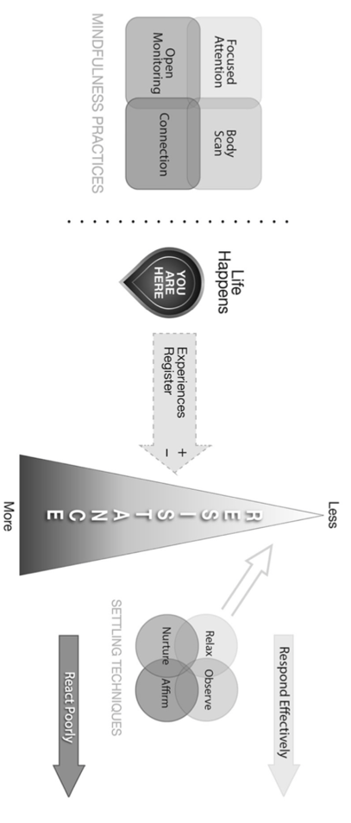
Challenging Situation No. 1 | Obstacles
Challenging Situation No. 2 | Obstacles
Challenging Situation No. 3 | Obstacles

As you reflect on your paper topic and the situations you will offer as examples of where mindfulness practice may be helpful, tease apart the “Challenge” from the “Obstacles.” This is an important distinction that we have discussed in class on several occasions and is explored throughout the class textbook. For example, your upstairs neighbors is making a lot of noise at night when you are trying to study (this is the Challenge; it is Life Happening). The Obstacle(s) is what emerges within you (T/F/S). You may find it helpful to also reflect on our discussion of Pain and Suffering.

